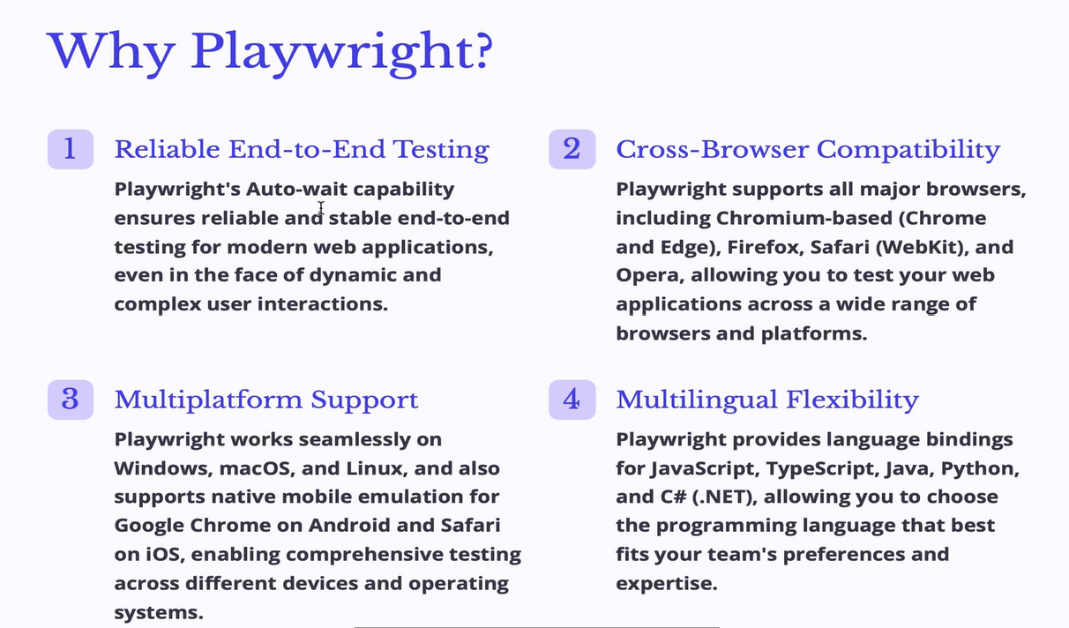

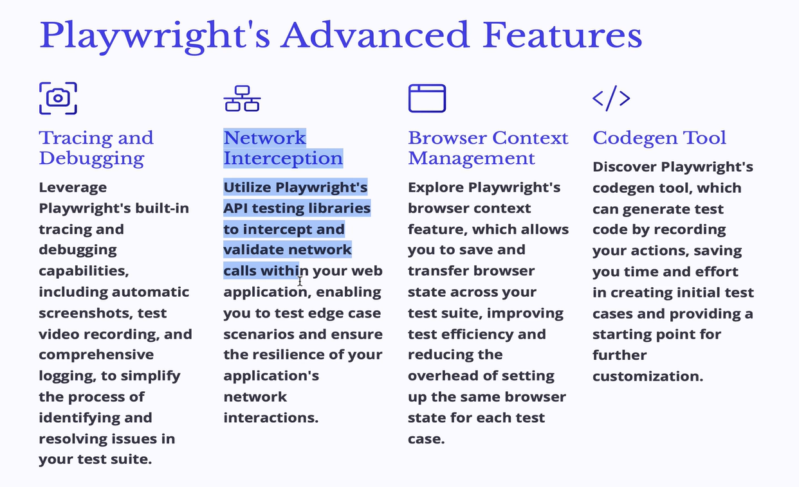

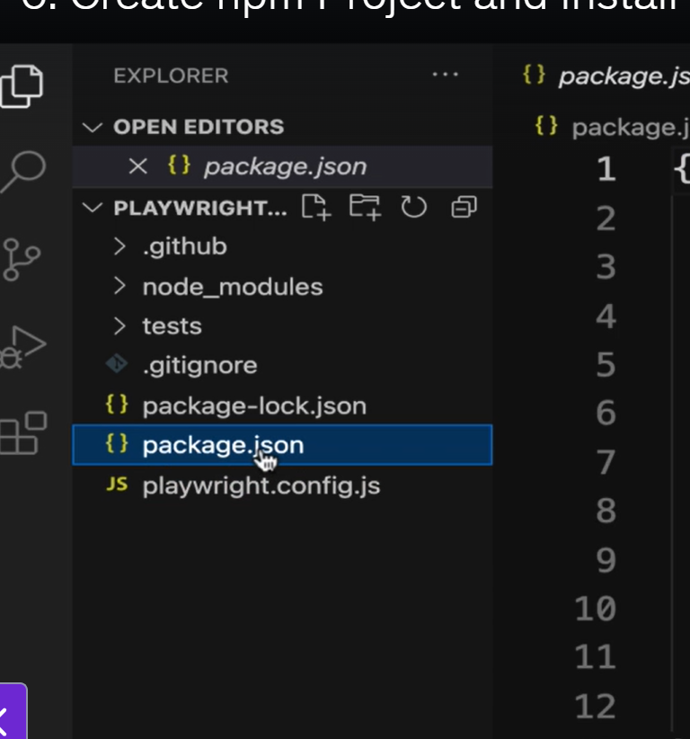

Config.js – act as a runner file in PlayWright tool.
Package.json – have dependencies mentioned into it.
Node-modules folder have all the playwright jars into it.

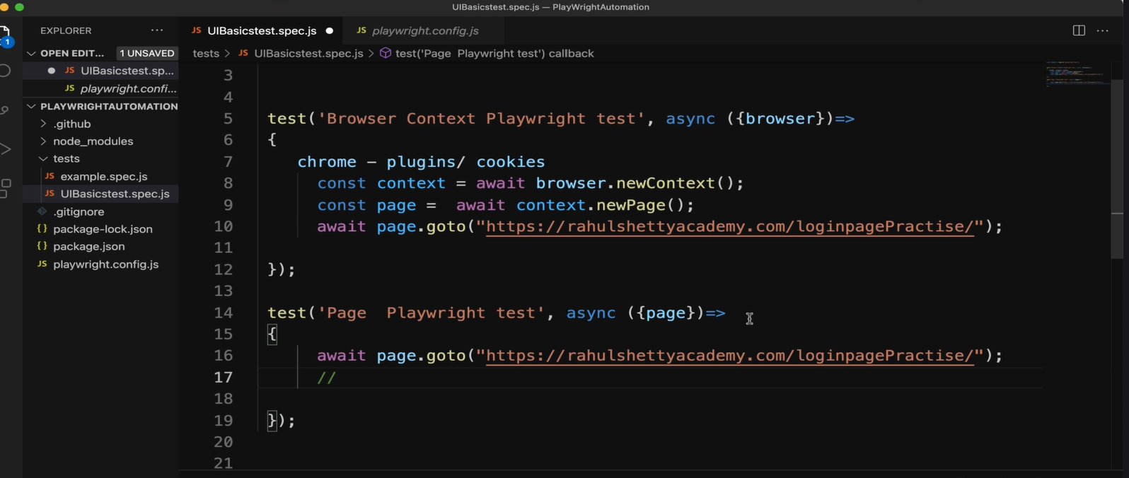
Browser and page are fixtures in playwright. There are total 4 fixtures.

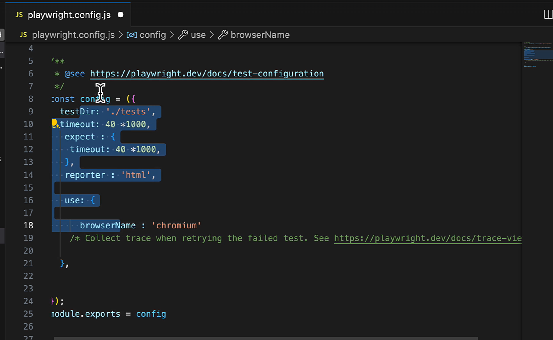

Timeout generic for all components. Expect{timeout} for assertion timeout.
Use {browser} – browser to be used.
Module.exports = config, to make sure that all modules uses config as runner settings.

